2.5" External SATA Hard Disk ENCLOSURE

Simply Add Your Own 2.5" Hard Disk
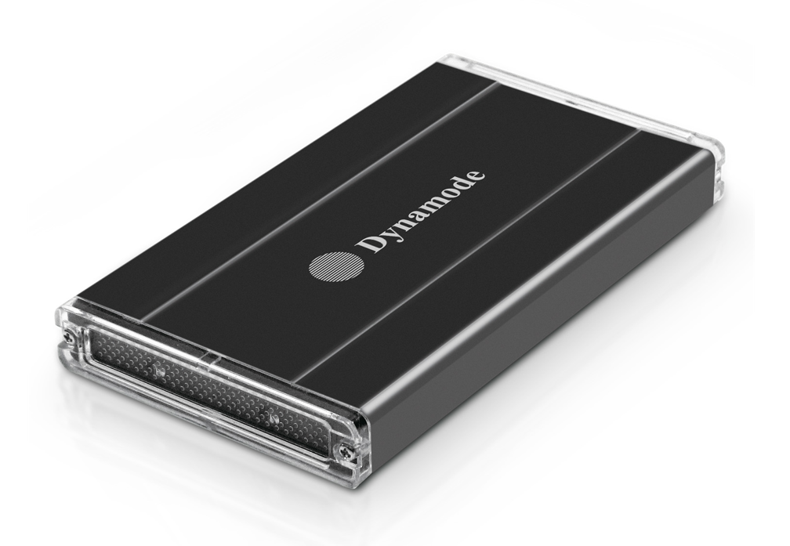

DESCRIPTION
The stylish USB-HD2.5SI features a high quality aluminium Enclosure with silent operation, ideal for your existing 2.5" SATA or IDE interfaced hard disk drives.

Fully Plug n' Play for leading Operating Systems including Microsoft Windows and Mac OS X, the USB-HD2.5SI allows your existing 2.5" SATA or IDE hard disk to be fitted quickly and with minimal effort.

FEATURES
> Stylish and portable aluminum design
> Ideal for your existing 2.5" SATA or IDE interfaced hard disk drives
> Re-use your laptop hard disk and keep your data when you upgrade
> Plug n' Play for popular Operating Systems - no drivers needed
> Powered by supplied USB2.0 cable -
no separate power supply required
> Backup and restore your data at up to 480Mbps

SPECIFICATIONS
Transfer interface: USB2.0
Transfer data: 480Mbps(MAX)
Hard disk type: 2.5" SATA or IDE interfaced hard disk
Working temperature: -40 ~ 65℃
Working humidity: 8% ~ 90%
Storage humidity: 5% ~ 95%
Operating systems: Windows98/ME/2000/XP/VISTA/7/8/10, Mac OS 8.6 or above

